**Plant Disease Detection Using Image Processing and**

**Machine Learning**

**Abstract:** One of the important and tedious task in agricultural practices is detection of disease on crops. It requires huge time as well as skilled labour. This paper proposes a smart and efficient technique for detection of crop disease which uses computer vision and machine learning techniques. The proposed system is able to detect 20 different diseases of 5 common plants with 93% accuracy.

**Key Features:**

**Dataset:**

For this project we have used public dataset for plant leaf disease detection called Plant Village curated . The dataset consists of 87000 RGB images of healthy and unhealthy plant leaves having 38 classes.

**Data pre-processing and feature extraction:**

Data pre processing is important task in any computer vision based system.. To get precise results, some background noise should be removed before extraction of features. So first the RGB image is converted to greyscale and then Gaussian filter is used for smoothening of the image. Then to binaries the image,. Then morphological transform is applied on binarised image to close the small holes in the foreground part. Now after foreground detection, the bitwise AND operation on binarised image and original colour image is performed to get RGB image of segmented leaf. Now after image segmentation shape, texture and colour features are extracted from the image. By using contours, area of the leaf and perimeter of the leaf is calculated.

**Classification Algorithm:**

Random forest classifier has been used for classification or detection task. It is the part of ensemble learning, where the output is predicted from multiple base estimators . Generally, to achieve higher accuracies, decision trees are used. But they are prone to overfitting problems. So to overcome this issue, random forest classifier is used which is a combination of multiple decision trees. Each tree is trained by using different subsets of the whole dataset, this can reduce the overfitting and improves the accuracy of the classifier.

**SUGGESTED SYSTEM:**

As a suggested solution for this issue that every farmer is facing, we are suggesting the use of the latest technologies to detect the plant disease detection which is image processing. The idea is to create a standalone application using MATLAB that will be used by the farmer. He will be uploading the image of the leaf to the application, once the image is processed and the detection is executed, the application will display to the farmers the type of disease along with the affected region, and the accuracy. The image that is uploaded to the standalone application will undergo the process of MATLAB throughout its image processing tools. By using MATLAB, features related to the area affected by the disease, the accuracy and many other features are analyzed. After MATLAB continues the processing of the given image, the type of disease is classified and detected. The core idea behind this system is to remedy the disease with minimum impact on the environment, and to guarantee for the user or the farmer a fast and economical way in detecting leaf disease and categorizing it

**IMAGES AND OUTPUTS GENERATED BY SYSTEM:**

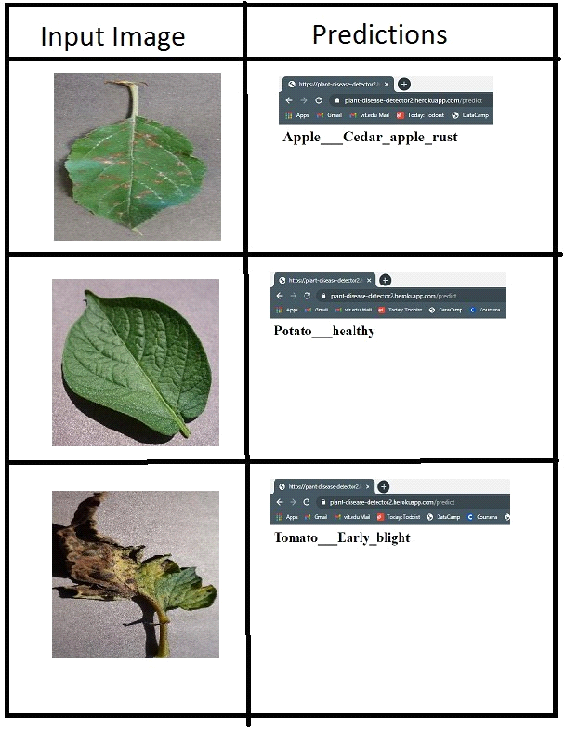

**BENEFITS OF DETECTION:**

**Early Detection:** Image processing allows for the early detection of diseases in plants. By analyzing images of plants, even before symptoms are visible to the naked eye, the system can identify subtle changes that indicate the presence of a disease.

**Precision and Accuracy:** Image processing techniques provide a high level of precision and accuracy in disease detection. This helps in distinguishing between different types of diseases and ensures reliable results.

**High Throughput:** Automated image processing systems can analyze a large number of plant images quickly. This high throughput is essential for monitoring large agricultural fields, ensuring that potential outbreaks are identified and addressed promptly.

**Cost-Effective:** Automated disease detection through image processing can be more cost-effective than manual methods. It reduces the need for extensive labor and allows for continuous monitoring without a significant increase in expenses.

**Quantitative Analysis:** Image processing enables quantitative analysis of disease severity. Instead of relying on subjective visual assessments, the system can provide quantitative data, which is valuable for researchers and farmers in understanding the extent of the problem.

**Remote Monitoring:** With the use of cameras and remote sensing technologies, plant health can be monitored remotely. This is especially useful for large agricultural areas, as it reduces the need for physical presence and allows for timely intervention.

**Conclusion :**

We have successfully developed a computer vision based system for plant disease detection with average 93% accuracy and 0.93 F1 score. Also the proposed system is computationally efficient because of the use of statistical image processing and machine learning model. Table 3 illustrates the overall benefits of our system over the other approaches.

This Project Carried out by

S. Vasanth (TL)

V. Vijay Avinash

C. Manimaran

T. Balaji